CHURCH GROUP: Good Shepherd Naperville Church
Hello Parents!
To register online with your church, you will need to go to the site below and follow the directions below to access the online registration system.
You will set up a new account and log in, which can be used now and, in the future, to access your account and sign-up for other programs.
Your GHR ID (Group Hold Registration ID) is: GSAB2023
CLICK HERE to access our NEW website and online registration system.
How to Register:
1. Click on the LINK above to go to the online registration page. When you get to the Login page, click on the button that says, "Create New Account."
2. The first screen is where you set up your username and password. The name and email address are for yours, not the person you are registering. Keep the username and password in a secure place and use it whenever you wish to return to update information or register for other camp sessions.
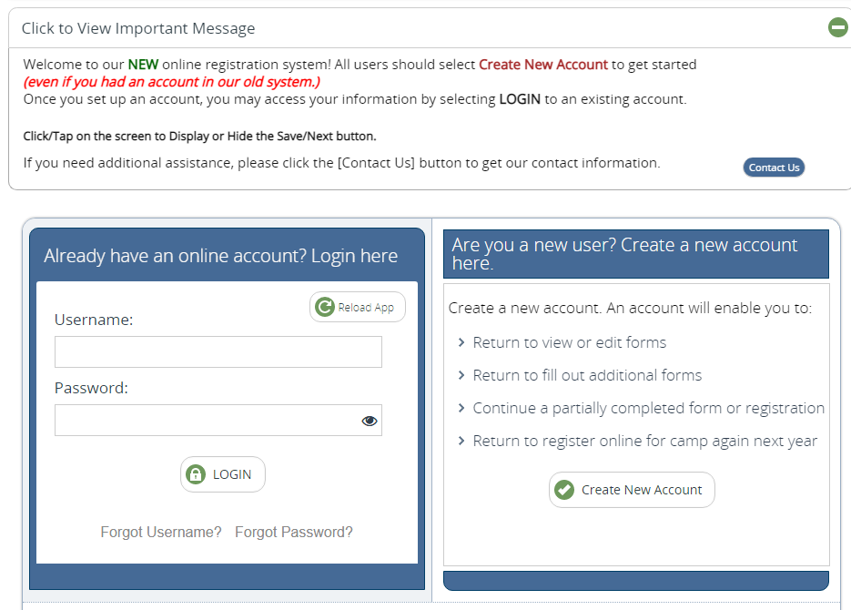
3. Once you have entered and confirmed the information, click NEXT, and the system walks you through each screen in the registration process.
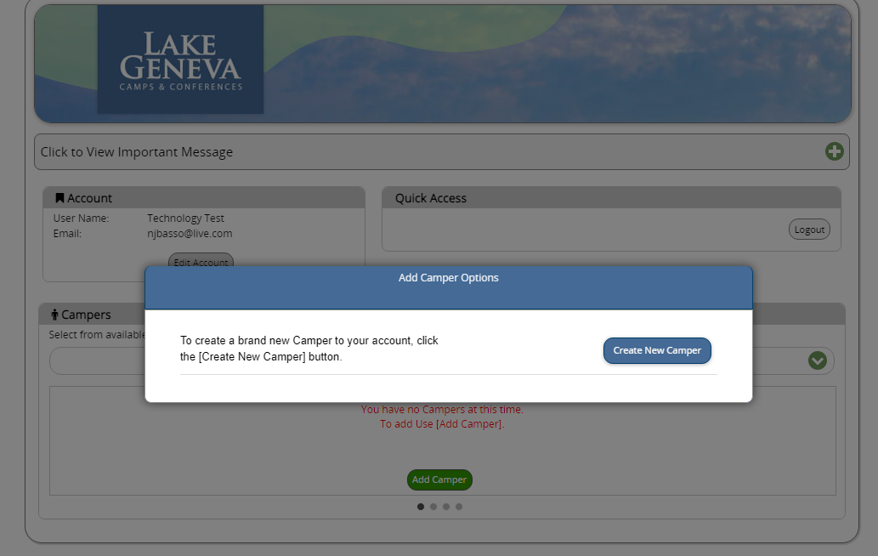
4. You must enter a GHR ID (GSAB2023) to connect your child with the church you are attending. You can find this code in the highlighted section near the top of these instructions.
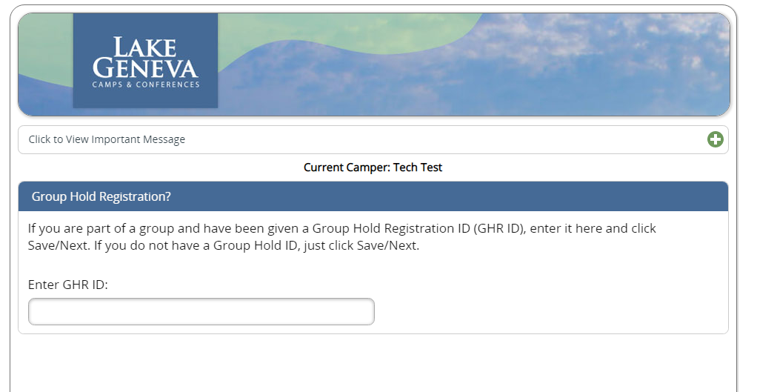
5. If you are registering more than one person, you will complete the registration for the first person and then click on "Add Camper."
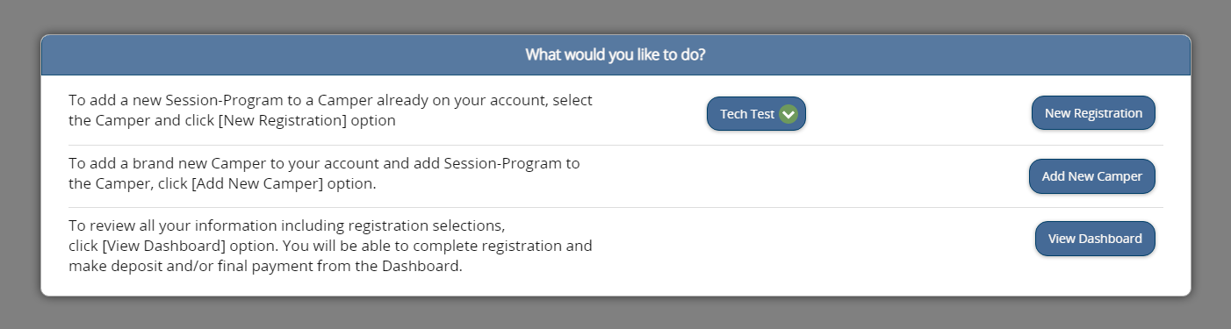
Or – you can visit the Dashboard for an overview of your account. You can access waivers and medical forms, as well as and complete any other open items here.
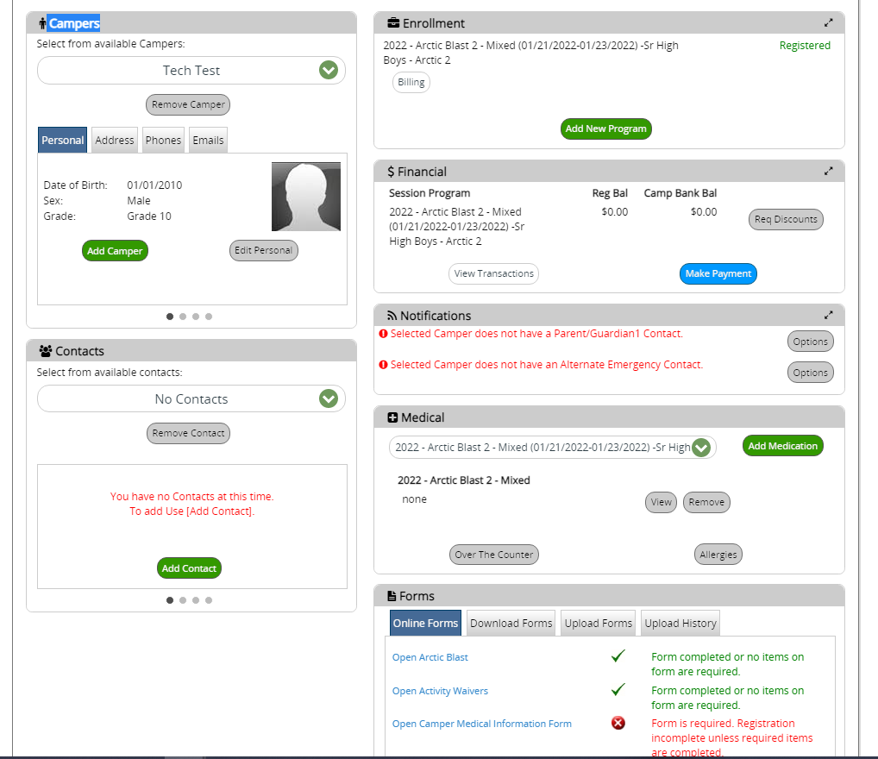

What else do you need to know?
You can pay the deposit and balance due through the registration system. If you encounter any issues or have a special payment situation – please email Uma or Taylor at registrar@lgyc.org and we can take care of this.
Experience any difficulties during the registration process? You will see a Contact Us button at the top of the screen that includes the technical support phone number and the camp phone number.
You may also reach us at registrar@lgyc.org – which is monitored regularly in the evenings and weekends.
Call or email us if you need assistance. We are so excited that your group is joining us this year at our upcoming Arctic Blast winter camp!
Taylor & Uma
The Registration Team at Lake Geneva Youth Camp
registrar@lgyc.org
262-248-5500
www.lgyc.org

